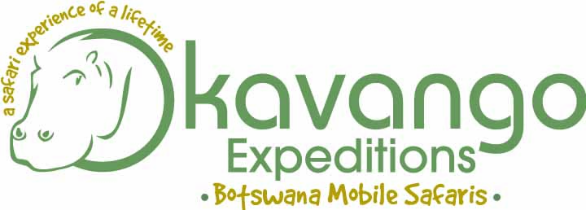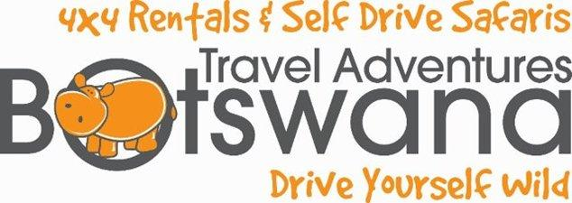
Responsible Tourism
We recognise that is our responsibility as a company to give back and to ensure that we make as small an impact as possible on the environment and as large an impact as possible on the development of our employees and surrounding communities. We want to make a difference to lives, sustainable differences that reach further than just the work place……… Differences that change lives for the better.
HIV and Aids initiative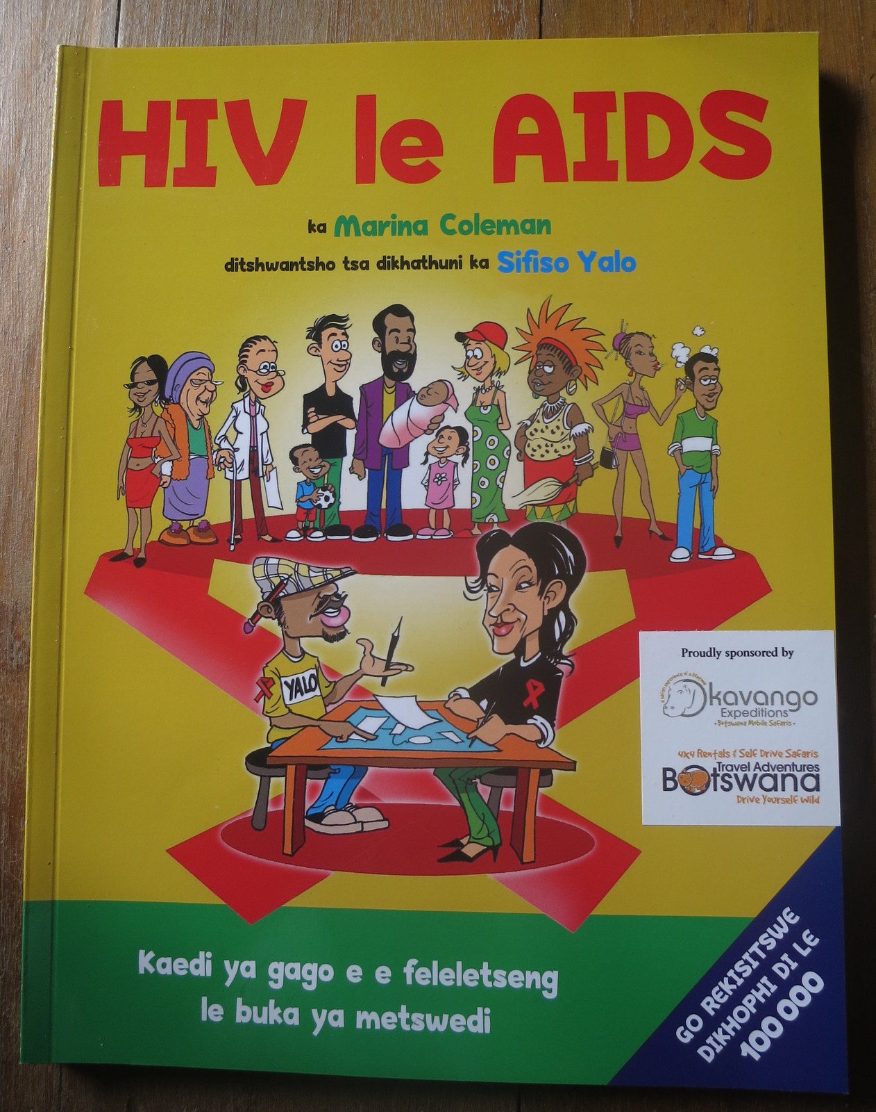
HIV and AIDs has sadly taken a negative toll on many in Botswana. We believe that knowledge is power and we have sponsored copies of the HIV &AIDs handbook by Marina Applebaum and Sifiso Yalo for our staff and our surrounding communities. Behaviour change amongst people is what is needed to stop the epidemic and the book deals with this pragmatically and clearly. We are motivating and empowering our employees and our neighbouring communities to take positive action in dealing with their health challenges. For more information on the hand book please visit Marina’s website www.appelbaum.co.za
Responsibility to our Employees
We recognise that our employees are our most valuable assets and as such we have chosen to invest in their development through training and skills development in work based skills sets as well as in life skills. We assessed each of our employees’ skills requirements and established where they would like to be in the next 5 and 10 years. With this information we have designed and implemented training programs for each individual employee ensuring growth in a their careers as well as in their lives in general
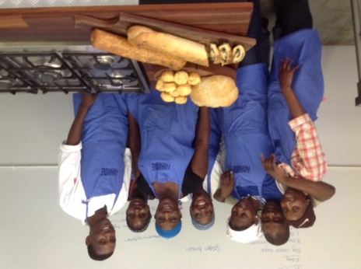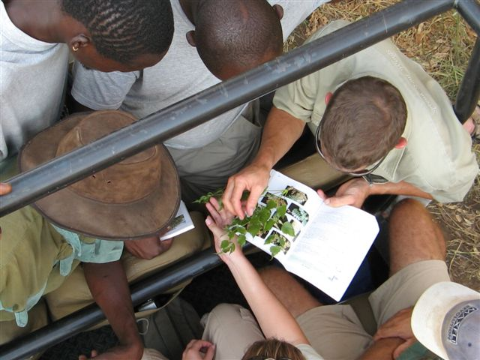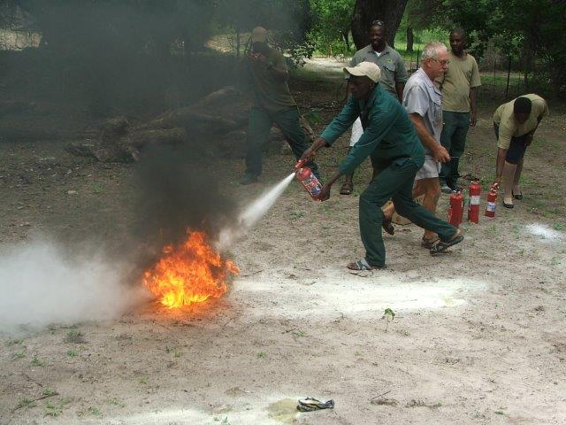
Environmental Responsibility
Okavango Expeditions is committed to minimizing our environmental impact and maximising our sensitivity to our environment. We do this through actively promoting the recycling of all our waste produced in our offices and on our safaris. All glass, plastic tin and paper products are separated and delivered to a collection depot in Maun where they are sent for recycling.
All our used engine oil is collected by Champs Botswana who either recycle or responsibly dispose of this waste (see www.champsbotswana.co.bw).

We encourage all our staff to commit to our recycling initiative and through education and training they are becoming the captains of this initiative in their communities.
Responsibility to our surrounding communities
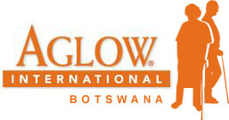
Okavango Expeditions has pledged our support to Aglow International whose focus is to support the destitute elderly within our community. “We believe that we are obligated to give back to those who made enormous sacrifices to put us through school, put bread on the table for us and clothes on our backs. It is how we treat our elderly that defines us as a nation”. An era of HIV aids has left a generation gap. Traditionally the middle aged would care for the elderly and the young. In Botswana due to HIV this has not happened and we have many elderly destitute folks. If you would like more info on Aglow and their amazing work in Maun with the Destitute Elderly within our community please contact us or Beauty Bogwasi. See their website for more informationwww.aglowinternationbotswana.org
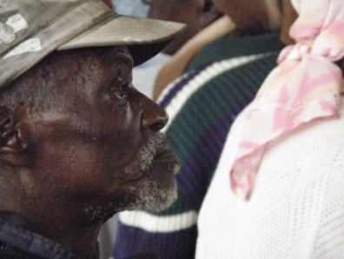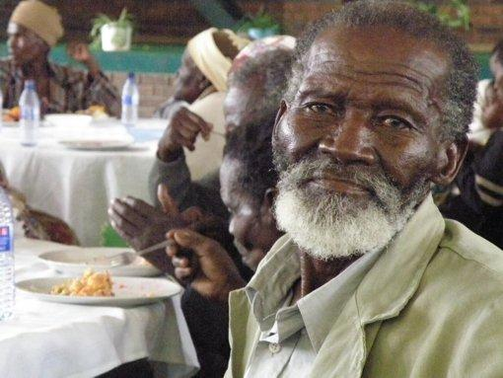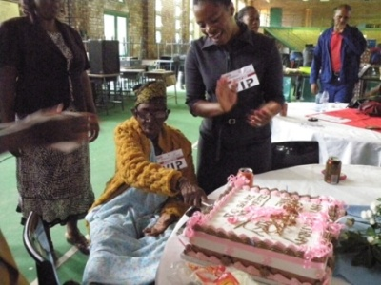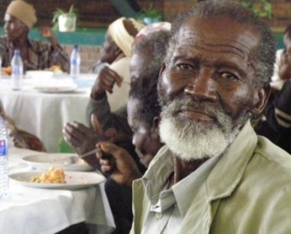
Mobile Safaris
Our serviced safaris spend 30% of the duration of the safari on local community owned and managed properties. During this time all our park entry and camping fees are paid directly to the communities in and around Khwai Village. Our Participation safaris contribute to the Okavango KopanoMekoro Community Trust for our Mekoro element of the tour. We pay the poler’s wages directly to the poler’s at the end of each mekoro trip.
Forthcoming projects
We are committed to growing our empowerment project and will soon be introducing new initiatives which will include:
Community vegetable garden – we have donated a piece of land to our neighbouring community and together with a local company in Maun, we will support the community by providing the expertise, seeds and irrigation materials to ensure a viable and successful project. Okavango Expeditions plan to purchase some of the produce from this project for our safaris and also for donation to Aglow International and similar projects. The balance will be sold at markets enabling the community to earn an income from the land.
Company football team – we believe that healthy and active bodies lead to healthy and active minds and what better way to encourage teamwork than through the sport of Africa – SOCCER. Our employees are all keen footballers and we have set aside some land to create a soccer field where they play during lunch and after hours. We will be sponsoring football kits and look at joining a league in which to compete in the near future.

